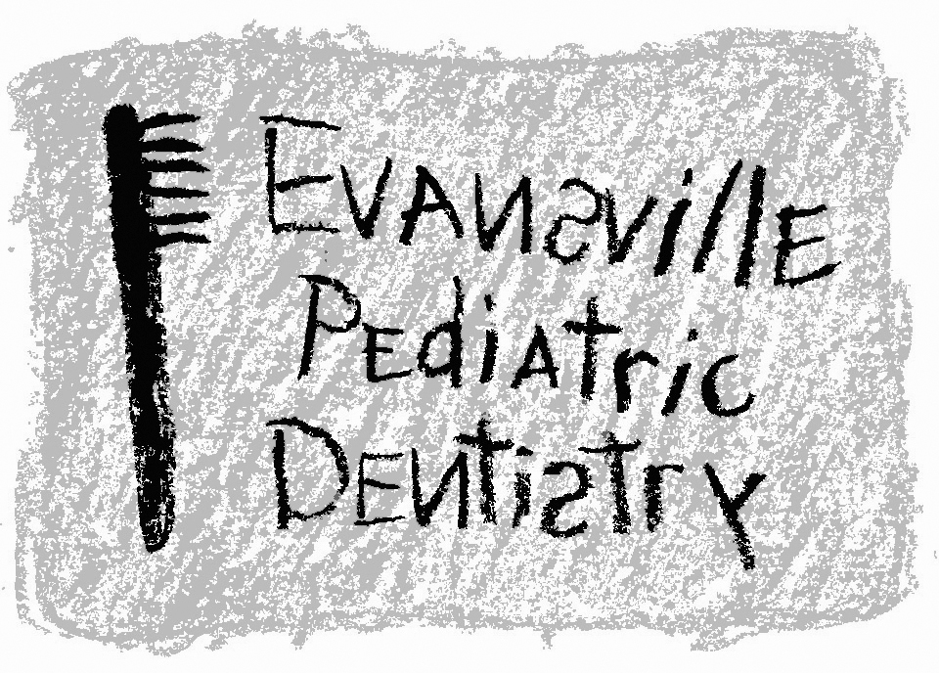
Jeffrey A. Hiester, D.D.S.
EAST WEST
7200 E. Virginia Street 2345 W. Franklin Street #101
Evansville, IN 47715 Evansville, IN 47712
(812) 479-8609 (812) 401-6095

Dear Parent,

As previously agreed upon, _____________________________________, is scheduled to have dental treatment at Surgicare Outpatient Surgical Center on ________________________________ at ____________________. He/She should report to the Surgery Center 1 ½ hours before the scheduled time of operation. Pre-operative instructions are listed below:

- No more than 30 days before the operation. Take your child to his/her pediatrician or family physician and have the doctor complete the following:
  - Physical examination
The physician/parent should have this completed 2 weeks prior to the surgery so that it may be on file at St. Mary’s Surgicare Outpatient Center and Evansville Pediatric Dentistry on the day of surgery. Fax number for St. Mary’s Surgicare is 812-475-1001, fax number for Evansville Pediatric Dentistry is 812-479-5554.

- Your child MUST HAVE NOTHING TO EAT OR DRINK after midnight the night before the surgery. (If your child has anything at all to eat or drink, the surgery will be cancelled and not rescheduled.)

- If you have dental insurance, your co-payment must be paid in full at least two weeks before the scheduled surgery. A treatment estimate will be provided to let you know the balance due. If the co-payment is not received, we may have to cancel the surgery.

- Please call our office one week before the surgery at (812) 479-8609, to let us know if everything is going as scheduled and that we may inform you of any last minute details.

- If there are any changes in your current phone number, please inform us as soon as possible. We also need another contact number other than the home number in case we have trouble reaching you.

If we do not hear from you and the surgery appointment is missed, we will
not be able to reschedule the surgery or see the patient in the office.
We need at least 2 weeks notice to cancel or change a surgery date.

